DESIGN AND IMPLEMENTATION OF A SPECIALIZED GENERAL STUDIES(GEDs) MANAGEMENT SYSTEM
BY

ANIEKE SOMTOCHUKWU HENRY 22/1833
FAJI BABASOLAPE OLUWADEMILADE 22/0655
OKWUDILICHUKWU OGAKWU 22/1042

A PROPOSAL WORK SUBMITTED IN PARTIAL FULFILMENT OF THE
REQUIREMENTS FOR THE AWARD OF BACHELOR OF SCIENCE B.SC(HONS) DEGREE IN COMPUTER SCIENCE

TO THE DEPARTMENT OF COMPUTER SCIENCE
SCHOOL OF COMPUTING
BABCOCK UNIVERSITY ILISHAN-REMO
OGUN STATE, NIGERIA
APRIL, 2026.

CERTIFICATION
This certification page is to certify that this project was carried out by the following students under my supervision in the Department of Computer Science, Babcock University, Ilishan-Remo, Ogun State, Nigeria.
ANIEKE SOMTOCHUKWU HENRY 22/1833
FAJI BABASOLAPE OLUWADEMILADE 22/0655
OKWUDILICHUKWU OGAKWU 22/1042

PROF. AFOLASHADE KUYORO _________________
(Project Supervisor) DATE

DECLARATION
We declare that this project, “DESIGN AND IMPLEMENTATION OF A SPECIALIZED GENERAL STUDIES (GEDs) MANAGEMENT SYSTEM" was carried out by the following people:

ANIEKE SOMTOCHUKWU HENRY _________________
22/1833 DATE
FAJI BABASOLAPE OLUWADEMILADE _________________
22/0655 DATE
OKWUDILICHUKWU OGAKWU _________________
22/1042 DATE

DEDICATION
To God, who has been the source of wisdom and strength throughout this project, we offer our sincerest thanks. Your guidance and grace have enabled us to persevere through the challenges and difficulties of this undertaking. To our supervisor, Prof. Afolashade Kuyoro, we express our deep appreciation for your unwavering support, guidance, and encouragement. Your insights and expertise have been invaluable in shaping our ideas and refining our work. To our guardians, we are forever grateful for your love, encouragement, and unwavering support throughout our academic journey. Your sacrifices and unwavering commitment have made this achievement possible. This project is dedicated to you all, with profound gratitude and appreciation for your guidance, support, and inspiration.

ACKNOWLEDGEMENT
We are deeply grateful to Almighty God for granting us the strength and wisdom to undertake and complete this project successfully.
We extend our sincere gratitude to our Dean, our Head of Department, Dr Seun Ebiesuwa, our supervisor, Prof. Afolashade Kuyoro, Dr Alfred Udosen, as well as our lecturers, whose guidance, support, and constructive feedback throughout this project were invaluable. We are grateful for the time and effort you invested in us and for sharing your knowledge and expertise, which have helped us develop our research and analytical skills.
We also want to express our appreciation to the School of Computing Sciences for providing us with the necessary resources and facilities to conduct this research. Our sincere thanks go to the lecturers, technical staff, and other members of the faculty who have imparted their knowledge and skills to us, enabling us to complete this project.
We would like to thank our friends for their encouragement, support, and motivation during the course of this project. Your unwavering support and understanding were invaluable to us, and we appreciate all the sacrifices you made to help us achieve our goals. Lastly, we would like to express our heartfelt appreciation to our parents for their love, support, and encouragement. Your unwavering faith in us has been our greatest source of strength, and we are grateful for everything you have done for us throughout our academic journey.

ABSTRACT

TABLE OF CONTENTS
CERTIFICATION 2
DECLARATION 3
DEDICATION 4
ACKNOWLEDGEMENT 5
ABSTRACT 6
TABLE OF CONTENTS 7
LIST OF FIGURES 9
CHAPTER ONE 9
INTRODUCTION 9
1.0 Background to the Study 9
1.1 Statement of the Problem 12
1.2 Aim and Objectives of the Study 12
1.3 Methodology Overview 13
1.4 Scope of the Study 14
1.5 Significance of the Study 14
1.6 Justification of the Study 14
1.7 Organization of Chapters 15
CHAPTER TWO 15
LITERATURE REVIEW 15
2.1 Conceptual Review 15
2.1.1 General Studies in Higher Education 15
2.1.2 Educational Management Systems 17
2.1.3 Learning Management Systems (LMS) and Their Role in Education 19
2.1.4 Web-Based Systems and Cloud Technologies in Education 21
2.1.5 Database Management Systems in Educational Platforms 22
2.1.6 Automation and Information Management in Higher Education 22
2.1.7 Challenges in Managing General Studies Programs 24
2.1.8 Specialized GEDs Management System 26
2.2 Summary Table of Reviewed Literature 29
2.3 General Comment 38
CHAPTER THREE 40
SYSTEM ANALYSIS AND DESIGN 40
3.1 System Analysis 40
3.1.1 Description of The Proposed System 40
3.1.2 System Objectives 41
3.2 System Design 42
3.2.1 System Architecture 42
3.2.2 The System Flowchart 43
3.2.3 Data Flow Diagram (DFD) 44
3.2.4 Use Case Diagram 46
3.2.5 Database Design 47
3.2.6 Input Design 49
3.2.7 Output Design 50
3.3 Requirement Analysis 50
3.3.1 Functional Requirements 50
3.4.2 Non-Functional Requirements 52
3.6 Development Tools 53
CHAPTER FOUR 55
IMPLEMENTATION 55
4.1 Introduction 55
4.2 Graphical View of the Project 55
4.3 System Modules and Feature Implementation 56
4.3.1 User Authentication and Access Control 56
4.3.2 Administrator Module 57
4.3.3 Student Module 60
4.3.4 Lecturer Module 62
4.3.5 Assessment and Grading Module 64
4.4 System Testing and Validation 67
4.5 Conclusion 67
CHAPTER FIVE 69
SUMMARY, CONCLUSION AND RECOMMENDATION 69
5.1 Summary 69
5.2 Conclusion 69
5.3 Recommendation 69
References 71

LIST OF FIGURES
Figure 3.1: The System Architecture Diagram 91
Figure 3.2: System Flowchart 93
Figure 3.3: Data Flow Diagram 94
Figure 3.4: Use Case Diagram 95
Figure 3.5: Entity Relationship Diagram 96

CHAPTER ONE

INTRODUCTION

1.0 Background to the Study
Digital platforms are being adopted in several tertiary institutions around the world to support how these institutions manage teaching, learning, and all-round student services. This has led to numerous universities and colleges embracing the use of Learning Management Systems (LMS) as their platform used to conduct course registration, track academic progress, and simplify communication between students and lecturers. Learning Management Systems (LMS) are especially helpful for institutions that manage both diverse programs and general curricula, as they grant easier access to materials, automate assessments, and accurately store records (Wong-Fajardo., 2021) (Zhang, 2024).
In the last couple of years, universities have been making use of these digital platforms a lot more to manage overall academic administration. The increase in the use of these Learning Management Systems (LMS) as well as whole-platform integration is the shift toward having a more centralized and accessible education system (Zhang, 2024) (Fibriasari, 2023). These systems make course enrolment and assessment easier to handle and also allow for easier communication between students and lecturers. However, most universities make use of a generalized platform to manage the entirety of its academic activities and thereby overlook the specialized needs of some areas of the curriculum, particularly transdisciplinary programs like General Studies (GEDs) (Decuypere, 2021).
At Babcock University, GEDs are required courses for all undergraduates. Courses like Philosophy, Communication, and Entrepreneurship, are taken to increase students’ discipline and expand both their intellectual and practical skills (Ayanbode, 2022). Presently, Babcock University makes use of its institutional platform, UMIS (University Management Information System), for course registration of all courses and computer-based tests for GEDs, as well as some departmental courses.
Though, UMIS effectively serves its general purpose, it does not have some important functionalities that are required when it comes to the specific needs of GEDs and its transdisciplinary nature. Students regularly encounter issues like fragmented access to materials, absence of a centralized mock exam repository, and reliance on manual grading, which increases lecturers’ workload and error risk (Adedoyin, 2023) (Ike, 2023) (Bayode, 2022).
The fragmented nature affects learning outcomes and general satisfaction among students. GEDs at Babcock University are managed using procedures that were not completely developed with its transdisciplinary needs in mind. GEDs courses span across different departments, different modes of content delivery, and high numbers of students, which are all factors that make them less effective to be managed using a one-size-fits-all platform such as UMIS (Decuypere, 2021) (Ike, 2023).
To address these issues, this project proposes the design and implementation of a specialized General Studies (GEDs) Management System, a web-based platform with the sole objective of managing all things related to GEDs courses in Babcock University. The system is going to handle course registration, centralize access to lecture materials and past questions, provide mock examinations, grade automatically, and help in improving communication between students and lecturers. Unlike UMIS, which deals with the entire university curriculum in general, this new system will be built with the specific needs of GEDs in mind.
With the design and implementation of the General Studies (GEDs) Management System, the platform will improve efficiency, reduce errors, enhance student engagement, and also support better academic outcomes for both students and lecturers involved in the General Studies program. Although similar course management systems already exist, none specifically addresses the transdisciplinary and the large-scale nature of GEDs courses (Zhang, 2024) (Wong-Fajardo., 2021).
In essence, aside from this project being necessary, it is also quite applicable, specifically in the case of Babcock University and its mission of ensuring holistic and technology-driven education. The General Studies (GEDs) Management system will provide a unified place for registration and grading, and will also create a more connected educational system in which students can access materials with ease, and lecturers can manage their content without stress. Altogether, this project will supports Babcock University’s wider mission to produce holistically balanced graduates.

1.1 Statement of the Problem
Despite the technological improvements being made in tertiary institutions, with the use of Learning Management Systems (LMS) and Student Information Systems (SIS) to aid academic administration, the management of transdisciplinary courses like General Studies (GEDs) are usually managed on general one size-fits-all-platforms which lack the ability to handle their unique needs. While systems like Babcock University’s University Management Information System (UMIS) efficiently manage course registration and computer-based testing, they lack features tailored to GEDs. Students currently have no dedicated platform for accessing lecture materials, assignments, or past questions, and therefore result to searching for resources that are scattered across different informal channels. This fragmented structure makes it difficult for students to stay organized and for lecturers to share materials or communicate effectively. Hence, there is a need for a specialized General Studies (GEDs) Management System that is unified, well-structured and designed to meet the transdisciplinary needs of GEDs courses.

1.2 Aim and Objectives of the Study
The aim of this study is to design and implement specialized General Studies (GEDs) Management System. The specific objectives are to:
1. design a specialized general studies (GEDs) management system.
2. implement a role-based portal specific to GEDs courses.
3. test the system’s performance under realistic conditions.

1.3 Methodology Overview
The development of the Specialized General Studies Management System for Babcock University involved a comprehensive review of existing academic management platforms to identify their strengths and limitations. The goal is to create an efficient, user-friendly system tailored to the specific needs of General courses (GEDs), focusing on enhancing course enrolment, progress tracking, and reporting processes.
The system architecture and workflow diagrams will be designed using tools like draw.io, providing a clear visual representation of the system's structure and functionality. A full-stack approach will be employed, utilizing Python with the Django framework for the backend and React.js for the frontend. This ensures a robust, responsive, and intuitive user interface.
The development process will consist of three key phases: planning and design, development, and testing. During the planning phase, system requirements were defined based on the operational needs of the university. The database will be structured to eliminate redundancies and enhance performance. Modular decomposition will be applied to identify essential features, such as user dashboards, course catalogues, and enrolment modules.
The chosen Django-React stack will be compared to alternative architectures, such as monolithic systems or frameworks like Laravel or Spring Boot, evaluating factors like scalability and deployment efficiency. This analysis confirmed the suitability of the selected stack for a customized, high-performance system.
The development phase will follow an iterative approach, with prototypes built and refined to ensure reliability and usability. The system will be designed to streamline complex workflows, reduce administrative overhead, and accommodate multiple user roles effectively. Comparisons with existing platforms, such as Moodle or Blackboard, will validate the system's tailored efficiency for the university context.
The system will be evaluated based on usability, performance, and functionality. By benchmarking against alternative solutions, the system will demonstrate its effectiveness and reliability in managing General Studies (GEDs) courses at Babcock University.

1.4 Scope of the Study
This study focuses on the design, implementation, and evaluation of a web-based General Studies (GEDs) Management System for Babcock University. The system will provide secure, role-based access for students, lecturers, and administrators to help manage GEDs courses more efficiently. It will not include non-GEDs courses and will also exclude UMIS-integrated services for now.

1.5 Significance of the Study
This study is significant because it tackles the inefficiencies in the way General Studies courses are currently managed at Babcock University. The platform will centralize course registration, material access, mock exams, and grading, and in turn provide a more organized learning environment for everyone involved, which supports the university's mission to produce well-rounded graduates.

1.6 Justification of the Study
This project is justified because it offers a dedicated solution to improve the management of General Studies (GEDs) courses and their unique needs. At Babcock University, the existing UMIS platform serves its general purpose, but implementing a dedicated platform specifically for GEDs' unique nature will ensure more efficient management and coordination. The system will essentially centralize the entire General Studies (GEDs) management and administration process, to create a more efficient and scalable digital model that supports the university’s goals.

1.7 Organization of Chapters
Chapter 1: This chapter examines the background of the project and gives an overview of what is covered in the application through research and implementation as well as the overall methodology.
Chapter 2: This chapter briefly discusses major concepts and theories associated with the implementation of the application as well as the approaches adopted in related and existing systems alongside examples of similar systems already in place. It also discusses limitations of the stated systems.
Chapter 3: This chapter discusses the system analysis and design as they are applied to this project, breaking down the requirements, processes involved, and tools for implementation.
Chapter 4: This chapter discusses the processes used to implement the system design, the software solution, and the management of other development constraints.
Chapter 5: This chapter is the last and acts as the conclusion. It includes a summary of the entire project, results, findings, and recommendations for further study.

CHAPTER TWO

LITERATURE REVIEW

2.1 Conceptual Review

2.1.1 General Studies in Higher Education
General Studies, also referred to as General Education (GEDS), represents a broad and compulsory component of undergraduate programs in Nigerian universities and many higher institutions globally. Its primary aim is to produce well-rounded graduates equipped not only with specialized disciplinary knowledge but also with transferable skills that promote civic responsibility, critical thinking, communication, and ethical reasoning. According to the (National Universities Commission, 2023) in its Core Curriculum and Minimum Academic Standards (CCMAS), every student regardless of their field of study is required to undertake a set of General Studies courses that foster intellectual breadth and social awareness. This national framework ensures that higher education extends beyond specialization, cultivating citizens who can contribute meaningfully to social and economic development.
Furthermore, General Studies programs are designed to integrate multiple disciplines such as communication skills, entrepreneurship, philosophy, science and technology, social sciences, and humanities. This multidisciplinary nature ensures that graduates possess the competence to adapt to complex societal and workplace challenges. As (Ayanbode, 2022) observe, the structure of General Studies in Nigerian universities plays a vital role in shaping students’ holistic development, improving their ability to collaborate, and enhancing their employability in diverse sectors. In essence, the General Studies curriculum is not just supplementary but foundational to producing balanced graduates capable of lifelong learning and civic engagement.
However, despite its academic importance, the administration of General Studies programs remains one of the most demanding aspects of university management, this difficulty arises primarily from how large the student populations enrolled in these courses and the multidisciplinary scope that involves multiple departments and lecturers. Manual processes for registration, result computation, and record management often lead to errors, duplication, delays, and, in some cases, the loss of data (Bayode, 2022) (Ike, 2023). These administrative inefficiencies not only affect institutional productivity but also influence the quality of learning experiences students receive.
Consequently, the increasing digitalization of higher education has revealed the urgent need to replace traditional paper-based operations with automated platforms, studies such as (Zhang, 2024) and (Wong-Fajardo., 2021) emphasize that technology-driven management systems are essential for handling high-volume academic data, improving transparency, and supporting continuous assessment. By leveraging such systems, both administrators and lecturers can manage enrolments, grading, and feedback processes more efficiently while also maintaining accuracy and accountability. Moreover, the integration of automation enhances communication among stakeholders, thereby promoting a more responsive academic environment.
In view of these developments, the concept of General Studies in modern higher education now extends beyond curriculum content to encompass the systems and structures that facilitate its delivery and administration, it is no longer sufficient to focus solely on what is taught as attention must also be given to how these programs are managed and evaluated. The effective management of General Studies therefore requires digital tools capable of integrating registration, attendance, communication, and grading within a unified platform and therefore the emergence of specialized GEDs Management Systems represents an innovative response to the administrative and pedagogical challenges of managing such multidisciplinary programs in Nigerian universities (Decuypere, 2021).

2.1.2 Educational Management Systems
Educational Management Systems (EMS) are digital platforms designed to simplify, coordinate, and enhance both administrative and instructional processes within academic institutions by integrating multiple functions such as student registration, course scheduling, attendance tracking, grading, and reporting into a unified and efficient. According to (Wong-Fajardo., 2021), Educational Management Systems provide universities with centralized control over their operations, enabling administrators and lecturers to manage large datasets with greater accuracy while also minimizing errors that often result from manual handling.
In earlier years, administrative tasks in most universities relied heavily on paper-based methods and fragmented digital tools, which frequently led to duplication, data loss, and weak communication among departments. With the introduction of Educational Management Systems, these limitations have been largely addressed through automation that streamlines workflows, enhances data reliability, and facilitates real-time information sharing across all academic units (Bayode, 2022) (Ike, 2023). These systems also support institutional decision making by offering structured access to academic data, performance reports, and analytics that inform planning, evaluation, and quality assurance, thereby reducing administrative bottlenecks and improving transparency across departments.
Furthermore, Educational Management Systems platforms foster collaboration among students, lecturers, and administrators by providing a shared environment for managing academic activities, Lecturers can upload and update course materials while students access results, submit assignments, and communicate with instructors within the same interface. Administrators, on the other hand, can monitor operations and generate reports through a centralized dashboard, ensuring that academic and administrative functions remain interconnected (Zhang, 2024). Such systems therefore act as bridges between institutional management and instructional delivery, creating a cohesive structure that aligns academic objectives with operational efficiency.
In addition, Educational Management Systems enhance accountability and data security by incorporating role-based access control, ensuring that only authorized users perform specific functions within the system (Wong-Fajardo., 2021), this layered structure reduces the risk of unauthorized access, protects sensitive academic data, and ensures compliance with institutional policies. As higher institutions continue to expand in size and complexity, these systems offer scalability and consistency that manual processes cannot sustain.
Overall, Educational Management Systems have evolved from being mere record-keeping tools to becoming integral components of educational transformation, combining automation, information management, and web technologies to create environments where accuracy, accessibility, and efficiency coexist. In the context of General Studies administration, Educational Management Systems form the backbone for specialized solutions such as the GEDs Management System, which extends the core functionalities of these platforms to meet the specific demands of managing large, multidisciplinary programs (Zhang, 2024).

2.1.3 Learning Management Systems (LMS) and Their Role in Education
A Learning Management System (LMS) is a software-based framework designed to facilitate the administration, delivery, and evaluation of learning and training programs within educational institutions, it serves as a digital hub that connects instructors, learners, and administrators through integrated tools for content management, communication, and assessment. According to (Decuypere, 2021), Learning Management System platforms have become essential components of modern higher education, enabling flexibility in teaching and learning while also supporting both synchronous and asynchronous instructional modes. By centralizing educational processes, Learning Management Systems enhance institutional efficiency, promote learner engagement, and ensure equitable access to academic resources regardless of physical location or time constraints (Fibriasari, 2023).
Types of Learning Management Systems
Learning Management Systems can be classified based on deployment models, ownership, and purpose, each serving distinct institutional needs:
- Installed (On-Premise) LMS: These are locally hosted systems installed on institutional servers, giving universities full control over data management, customization, and security. However, they require substantial technical infrastructure and maintenance.
- Cloud-Based (SaaS) LMS: These are delivered via the internet and managed by third-party providers, these systems offer scalability, accessibility, and cost efficiency, making them ideal for institutions with limited IT resources (Wong-Fajardo., 2021).
- Open-Source LMS: Platforms such as Moodle and Canvas fall into this category, allowing institutions to modify source code freely. They are cost-effective and adaptable but demand technical expertise for installation and support (Fibriasari, 2023).
- Commercial or Proprietary LMS: These systems are developed and licensed by private vendors examples include Blackboard, Schoology, and Google Classroom providing professional support, advanced analytics, and integration options at a higher subscription cost.
- Academic vs. Corporate LMS: Academic LMS are tailored to formal education environments, emphasizing course management and assessment, while corporate LMS are designed for employee training and skill development in organizations.
Each category offers distinct advantages depending on institutional goals, technical capacity, and user requirements, but the overall aim remains the same which is to streamline learning processes, foster communication, and enhance instructional delivery.
Beyond classification, the role of Learning Management System in education extends into academic transformation and institutional management, these platforms enable instructors to upload course materials, conduct assessments, and monitor learner progress, while administrators gain access to analytics that inform academic planning and quality assurance (Rohit, 2021). The widespread adoption of Learning Management Systems during the COVID-19 pandemic further demonstrated their critical function in maintaining educational continuity (Sofi-Karim, 2022). Moreover, recent technological advancements have expanded LMS capabilities through artificial intelligence, adaptive learning, and mobile integration, allowing for more personalized learning experiences and efficient data-driven decision-making. Consequently, the Learning Management System has evolved into a strategic infrastructure that supports not only teaching and learning but also institutional governance. Its framework provides the conceptual and technological foundation for specialized solutions such as the GEDs Management System, which applies these principles to the management of multidisciplinary General Studies programs in higher education (Zhang, 2024).

2.1.4 Web-Based Systems and Cloud Technologies in Education
Web-based systems and cloud technologies have redefined educational delivery by providing digital infrastructures that support remote access, scalability, and data-driven learning management. These systems allow institutions to host applications and data online rather than relying on local servers, thereby improving accessibility, collaboration, and cost efficiency. Cloud-based education technologies can be classified into three primary models: Software as a Service (SaaS), where applications such as Learning Management Systems are accessed via browsers; Platform as a Service (PaaS), which provides environments for developing and customizing educational tools; and Infrastructure as a Service (IaaS), which offers virtualized computing resources for hosting institutional databases (Wong-Fajardo., 2021). The adoption of these models enables universities to deliver content efficiently, ensure real-time collaboration, and scale their operations without major hardware investments. Moreover, cloud integration enhances security, data recovery, and interoperability across devices, ensuring continuity in learning and administration. In essence, web-based and cloud-driven systems have become indispensable in higher education, forming the technological backbone for advanced platforms such as the GEDs Management System, which leverages these tools to improve accessibility, automation, and academic coordination (Zhang, 2024).

2.1.5 Database Management Systems in Educational Platforms
Database Management Systems (DBMS) play a fundamental role in educational platforms by organizing, storing, and securing institutional data such as student records, course materials, grades, and administrative information. They serve as the backbone for managing large volumes of academic data efficiently while ensuring integrity, scalability, and controlled access (Bayode, 2022). A Database Management System provides structured mechanisms for data manipulation through operations such as querying, updating, and reporting, enabling institutions to maintain accuracy across interconnected modules, according to (Ike, 2023) there are several types of database systems commonly applied in education:
- Relational databases, such as MySQL and PostgreSQL, which organize data in structured tables linked by relationships
- Object-oriented databases, which store complex data models used in multimedia-based learning systems
- NoSQL databases, like MongoDB, which are optimized for flexibility and large-scale web applications
These systems support user authentication, data consistency, and backup management, ensuring that educational applications function reliably and securely. In the context of a GEDs Management System, Database Management Systems integration enables real-time record updates, transparent result computation, and efficient information retrieval, making it a critical component for sustaining accuracy and accountability within academic management.

2.1.6 Automation and Information Management in Higher Education
Automation and information management have become critical components of modern higher education, transforming how institutions handle academic, administrative, and operational tasks. In an academic context, automation refers to the use of digital technologies to execute repetitive processes such as registration, grading, attendance tracking, and report generation without the need for continuous human intervention. Through automation, institutions can reduce manual errors, increase operational speed, and ensure data consistency across departments while Information management, on the other hand, focuses on the systematic collection, organization, storage, and dissemination of institutional data, allowing administrators to make informed decisions based on accurate and timely information (Ike, 2023).
The integration of automation into educational systems has streamlined numerous academic activities that were once prone to inefficiency and delay, for example, automated grading tools and database-driven record systems have minimized administrative workloads while improving transparency and accountability in result processing (Bayode, 2022). Similarly, automated notifications, attendance systems, and digital assessment platforms ensure that both staff and students remain engaged within the academic cycle without unnecessary paperwork or communication breakdowns. According to (Zhang, 2024), institutions that implement information-driven automation experience improved coordination between faculties, better monitoring of student performance, and enhanced responsiveness to academic queries.
Moreover, automation supports institutional data management by linking academic units through centralized databases and dashboards that provide real-time insights into student progress, course delivery, and resource allocation (Wong-Fajardo., 2021). This data-driven approach enables predictive analysis for academic planning, helping institutions identify trends and make strategic adjustments. Consequently, automation and information management not only enhance administrative accuracy but also represent the backbone of institutional efficiency, accountability, and innovation in higher education.

2.1.7 Challenges in Managing General Studies Programs
The administration of General Studies programs in higher education presents several interconnected challenges arising from their multidisciplinary nature, large student enrollment, and the continued reliance on fragmented management approaches. These challenges can be categorized into the following key areas:
- Coordination and Administrative Complexity
General Studies programs involve multiple faculties and departments, each contributing courses that differ in structure, duration, and assessment methods, this interdepartmental arrangement creates significant coordination difficulties, resulting in overlapping timetables, course duplication, and inconsistencies in supervision (Ayanbode, 2022). The absence of a centralized administrative framework further compounds these issues, leading to inefficiencies in course allocation, record-keeping, and communication among academic units.
- Data and Record Management Challenges
One of the most persistent difficulties in managing General Studies programs is the handling of large volumes of academic data. Student registration, attendance tracking, grading, and result compilation are often managed manually or with basic spreadsheets, which increases the risk of human error, duplication, and data loss (Bayode, 2022). The absence of a unified database system also prevents seamless data integration across departments, limiting administrators’ ability to access reliable records or generate accurate academic reports, such inefficiencies hinder institutional transparency and delay essential processes like result computation and transcript preparation.
- Assessment and Feedback Inefficiencies
The process of conducting assessments and managing feedback remains another critical challenge. Manual grading methods and paper-based submission systems are time-consuming and prone to miscalculations (Ike, 2023). Additionally, delays in the release of results negatively affect student morale and institutional credibility, the lack of standardized digital assessment tools restricts lecturers’ ability to provide prompt and consistent feedback, thereby weakening the academic engagement process and reducing the effectiveness of instructional delivery (Zhang, 2024).
- Communication Barriers
Ineffective communication between administrators, lecturers, and students contributes significantly to the operational difficulties of General Studies programs. Information concerning course registration, class schedules, or policy updates is often disseminated through uncoordinated or non-digital channels, leading to misinformation, missed deadlines, and confusion among students. These challenges are further intensified in institutions with high student populations, where manual communication methods cannot accommodate the required level of information flow.
- Resource and Infrastructure Limitations
Many institutions face constraints related to funding, technical infrastructure, and human capacity. The lack of investment in Information and Communication Technology (ICT) facilities limits the development and maintenance of digital management systems. Furthermore, inadequate technical expertise among staff reduces the efficiency of existing systems, reinforcing dependence on outdated administrative practices that are no longer sustainable in the digital era.
- Need for Digital Integration and Reform
The cumulative effect of these challenges underscores the urgent need for a centralized, technology-driven solution that integrates academic and administrative processes within a unified system. A Specialized GEDs Management System directly addresses these limitations by automating workflows, promoting real-time data access, enhancing transparency, and supporting evidence-based decision-making. Through such innovation, institutions can strengthen accountability, streamline operations, and align with contemporary trends in higher education digital transformation (Zhang, 2024).

2.1.8 Specialized GEDs Management System
A Specialized General Studies (GEDs) Management System is a customized digital framework designed to automate, coordinate, and enhance the administration of General Studies programs within higher institutions, unlike general-purposes Learning Management Systems (LMS) or Educational Management Systems (EMS), this platform is developed specifically to address the complexities of managing large, interdisciplinary courses that span multiple departments and faculties. It integrates vital administrative and instructional functions such as student registration, course allocation, timetable scheduling, assessment submission, grading, and report generation into a single, coherent structure (Bayode, 2022). The system operates on the principles of automation, database management, and web-based architecture, ensuring that every academic activity ranging from enrollment to result computation is processed efficiently and accurately. Through a centralized data repository, it eliminates redundancy, promotes data consistency, and facilitates transparent communication among stakeholders.
A Specialized GEDs Management System typically draws its functionality from established digital education technologies, It incorporates features of Learning Management Systems (LMS) for online course delivery and assessment, Database Management Systems (DBMS) for secure storage and retrieval of academic records, and web-based cloud interfaces for accessibility and scalability (Zhang, 2024), By integrating these components, the system provides a unified environment that supports real-time interaction between administrators, lecturers, and students. Additionally, it enhances accountability through secure authentication, role-based access control, and automated computation of grades and performance (Ike, 2023). The inclusion of analytical dashboards and data visualization tools allows administrators to generate insights that inform institutional decision-making and academic planning. The adoption of a Specialized GEDs Management System is driven by the increasing complexity of General Studies programs in Nigerian universities, where large student populations and multidisciplinary course structures often create administrative bottlenecks, Traditional manual processes are time-consuming, very prone to error, and are incapable of providing real-time feedback or efficient data handling. In contrast, this system ensures accuracy in record management, reduces administrative workloads, and fosters collaboration between departments through automated workflows. Moreover, it supports continuous learning and assessment by enabling students to access materials, submit assignments, and monitor their progress remotely, thus promoting inclusivity and flexibility in higher education.
Beyond administrative automation, the system aligns with broader institutional goals of digital transformation and quality assurance. By ensuring transparency in result processing and simplifying academic supervision, it strengthens institutional accountability and compliance with the standards set by the National Universities Commission (NUC). Furthermore, its scalability allows universities to expand enrollment without compromising efficiency, while its modular design enables future integration with emerging technologies such as artificial intelligence and data analytics for predictive academic performance tracking, in essence, the Specialized GEDs Management System represents a transformative step toward modernizing the administration of General Studies programs, bridging the gap between institutional Practice and institutional management, and supporting the realization of efficient, technology-driven higher education in Nigeria.

2.2 Summary Table of Reviewed Literature

S/N | Author(s) (Year) | Project title | Objective | Methodology | Strength(s) | Weakness(es)
1 | Kateryna V. Vlasenko; Sergii V. Volkov; Iryna V. Lovianova; Olena O. Chumak; Irina V. Sitak; (2021) | Management of Online Platform Development and Support Process (CTE Workshop Proceedings, Vol. 8) | To design and manage an online educational platform (“Higher School Mathematics Teacher”) combining educational principles with software development to support learning and team collaboration. | SDLC with Agile/Scrum for development; ADDIE for course design; Bloom’s taxonomy for assessments; surveys for usability and team collaboration evaluation. | Well-defined roles and responsibilities enabled smooth development; high team and user satisfaction (team 4.61/5; users 4.64/5); effective combination of educational and technical best practices. | Mobile optimization needed; interactivity features basic; scalability to larger institutions untested.
2 | Mathias Decuypere; Emiliano Grimaldi; Paolo Landri (2021) | Introduction: Critical Studies of Digital Education Platforms (Critical Studies in Education) | To analyze how digital platforms transform education and to argue for critical approaches to studying platform effects on teaching, learning and governance. | Conceptual/critical analysis drawing on platform studies and case discussions. | Provides a detailed critical perspective on platformization; highlights socio-technical and governance implications. | Primarily conceptual with few practical instances; under-addresses smaller/local platforms.
3 | Oluyemi Folorunso Ayanbode; Abimbola Fagbe; Ruth Owolabi; Sunday Oladipo; Olasunbo Ruth Ewulo (2022) | Students’ interactions, satisfaction, and perceived progress in an online class: Empirical evidence from Babcock University Nigeria (Cogent Education) | To investigate how student–student, student–teacher and student–content interactions affect satisfaction and perceived progress, and the mediating role of satisfaction. | A survey of 385 students (63.64% response rate) was conducted and analyzed using SPSS and AMOS 23. Structural Equation Modeling (SEM) and Confirmatory Factor Analysis (CFA) were employed to test the hypothesized relationships among variables. | Strong theoretical base (Moore 1989); reliable statistical methods; demonstrates student-teacher interaction as most influential; shows interaction → satisfaction → perceived progress relationships. | Single-institution study (limits generalizability); omitted variables (socioeconomic, tech access) not included.
4 | Zhenyu Zhang (2024) | Design and Implementation of General Education Courses System Based on Curriculum Network (IEIT 2024 Proceedings) | To design a network-based virtual platform to enhance general education via resource sharing, interactive teaching and innovative assessments. | UML modelling; B/S architecture; Visual Studio, ADO.NET, SQL Server; adaptive/random question generation techniques. | Streamlined online teaching, homework management and resource sharing; adaptive assessments; supports tailored functions for roles; real-time automated tools. | Dependent on high-quality internet; complex architecture may limit low-resource accessibility.
5 | Ojowa Afolayan Bayode (2022) | Design and Implementation of School Management System (B.Sc. project report, National Open University of Nigeria) | To replace manual school administration with an automated, web-based School Management System to handle attendance, grading, communication, etc. | HTML/CSS/JS/PHP/MySQL; MVC architecture; NetBeans; Apache2. | Time-saving automation, flexible design, all-in-one features (library, fees, transport); user-friendly. | Lacks advanced analytics; internet-dependent; initial learning curve; potential bugs.
6 | Emma Margarita Wong-Fajardo; Hugo Saavedra-Sánchez; Mery Mendoza-Rodas; Ronald Hernández-Vásquez (2021) | Design and Implementation of an Integrated Academic Management Model with LMS: A Peruvian Private University Study Case (CEUR Proceedings) | To create an integrated academic management + LMS model that emphasizes competency-based education and real-world skills alignment. | Microsoft/Ubuntu servers; MySQL; PHP; Bizagi for process mapping; SCRUM for development. | Unified platform simplifies course planning, real-time updates, competency focus; flexible and customizable; saves teacher time. | Tech-heavy setup; tested at single university (scalability unknown); internet dependence.
7 | Ifeanyi Ike (2023) | Design and Implementation of a Student Information System (Project report, Federal University Otuoke) | To digitize student data and automate course registration, submissions, and record-keeping to replace error-prone paper methods. | Python (Flask), HTML/CSS/JS, MongoDB; three-layer architecture; Rapid Application Development (RAD). | Simple, mobile-friendly interface; real-time access; reduced errors; secure centralized storage. | Narrow scope (one department); internet required; could benefit from analytics and broader integration.
8 | Rohit; Peter Grabusts; Artis Teilans (2021) | E-Learning: Developing Tomorrow's Education (Proceedings, Rezekne Academy) | To identify effective e-learning practices and explore AI personalization, flexible delivery modes and interactive features for scalable education. | Discussion and conceptual synthesis; references to neural networks, interactive tools and platforms. | Emphasizes personalized AI-driven learning, flexibility, eco-friendly aspects; proposes interactive features. | Limited concrete case studies or implementation evidence; privacy/data protection not deeply addressed.
9 | H. Fibriasari; W. Andayani; T.T.A. Putri; N. Harianja (2023) | Learning Management System Now and in the Future: Study Case from the Indonesian University Students (International Journal of Information and Education Technology) | To explore student perceptions of LMS use during COVID-19 and potential future developments. | Interviews and focus group discussions (20 students); thematic analysis. | Highlights LMS convenience, flexibility; improved communication; concrete student feedback. | Small sample; internet/connectivity remains major constraint; technical limitations in LMS.
10 | Adedoyin, A.; Enebe, F. O.; Oyekunle, R. A.; Balogun N. A. (2023) | Design and Implementation of an Online Teaching and Learning Management System (FUDMA Journal of Sciences) | To build an easy-to-use online system combining course creation, grading and virtual classrooms for low-resource settings. | PHP + Vue.js front-end; NoSQL database; virtual classroom features. | High user satisfaction (>90%); simple, integrated platform reducing app switching. | Poor mobile performance; lacks team-teaching features and downloadable reports.
11 | Mahdi Sofi-Karim; Ahmed Omar Bali; Kardo Rached (2022) | Online Education via Media Platforms and Applications as an Innovative Teaching Method (Education and Information Technologies) | To study teachers’ attitudes and obstacles to online teaching in developing contexts, using English teachers in Iraq as a case. | Large survey (968 teachers via Google Forms); quantitative analysis. | Reveals the practical constraints (internet access, device shortage, training needs); provides policy-focused recommendations. | Focused on one subject (English) and one country; recommendations require significant investment.

2.3 General Comment
From the review of existing literature, it is evident that several researchers have explored various aspects of automation, learning management, and digital transformation in higher education. The studies by (Bayode, 2022), and (Ike, 2023) demonstrate that digital automation and database management significantly enhance accuracy, speed, and accessibility in academic administration. Similarly, works such as (Zhang, 2024)and (Wong-Fajardo., 2021) highlight the importance of cloud-based and network-integrated systems for improving coordination and scalability in university management.
However, the reviewed literature also reveals that most existing systems focus on general institutional management, rather than addressing the unique administrative and interdisciplinary structure of General Studies (GEDs) programs. Studies such (Ayanbode, 2022) confirm that these programs face complex challenges in communication, data management, and result processing due to their cross-departmental nature. Moreover, several systems such as (Adedoyin, 2023) (Fibriasari, 2023) still rely heavily on stable internet connectivity and lack mobile or multi-user adaptability, which limits their effectiveness in resource-constrained environments like Nigerian universities.
Therefore, the reviewed works collectively underscore a persistent gap which is the absence of a specialized, integrated, and scalable platform that consolidates administrative workflows, automates record processing, and enables seamless communication across departments within General Studies programs. This gap provides the conceptual and empirical justification for the development of the Specialized GEDs Management System, which aims to deliver a centralized digital framework that aligns automation, database management, and web technologies to improve efficiency, transparency, and accountability in the administration of General Studies in higher institutions.

CHAPTER THREE

SYSTEM ANALYSIS AND DESIGN

3.1 System Analysis

3.1.1 Description of The Proposed System
The proposed system is being designed as a Specialized General Studies (GEDs) Management System, developed to centralize, automate, and streamline all academic and administrative processes related to the management of General Studies programs in higher institutions. This initiative is addressing the long-standing problem of fragmentation, where processes such as student registration, course allocation, grading, and performance tracking are often handled separately across different departments and manual systems. By unifying these disconnected procedures, the system is creating a single point of coordination for all GEDs activities.
The Specialized system is serving as a comprehensive digital ecosystem that brings together all stakeholders that is the students, lecturers, and administration into one integrated web platform. It is enabling real-time communication, automated workflows, and data synchronization across every stage of the General Studies process, through this structure, institutions are gaining the ability to manage course delivery, assessment, and academic reporting from a unified interface, thereby reducing redundancy, administrative delays, and data inconsistencies.
Unlike general-purpose Learning Management Systems (LMS), this system is being specifically developed for the unique structure of GEDs programs, which typically cut across multiple departments and faculties. Each course, lecturer, and student is being linked through a centralized database, ensuring that all information from course outlines and multimedia content to assessment records and attendance data are securely stored, easily retrieved, and continuously updated. This centralization is eliminating the need for multiple record systems and ensuring data accuracy and transparency.
Technically, the system is being built with Python (Django Framework) as the core backend technology, supported by the Django REST Framework for efficient API communication and modular scalability. The front-end is being developed with HTML, CSS, and JavaScript, ensuring responsive interaction across devices. SQLite is working as the primary database engine for structured storage and quick data retrieval. Together, these technologies are allowing seamless interaction among the three major user roles which is the Students, Lecturers, and Organizations (Administrators) each with specific permissions and functionalities designed to suit their responsibilities within the GEDs ecosystem.
By integrating automation, data centralization, and user interactivity, the system is transforming the management of General Studies into a coherent, data-driven process that supports both institutional efficiency and student learning outcomes and it is ensuring that all GEDs-related activities, once scattered across different platforms or manual registers, are now aligned within a single digital framework that promotes accessibility, transparency, and academic accountability.

3.1.2 System Objectives
The objectives guiding the design and development of the Specialized GEDs Management System are as follows:
- To develop a web-based academic platform that automates the management of General Studies courses and records.
- To centralize all GEDs administrative and academic operations into a single digital environment.
- To facilitate seamless communication and interaction among students, lecturers, and administrators.
- To provide lecturers with analytical tools for course creation, grading, and student performance tracking.
- To integrate interactive learning through videos, notes, quizzes, and progress analytics.
- To ensure secure user authentication, reliable data management, and scalable performance across all modules.
- To promote transparency, accountability, and efficiency in the coordination of General Studies programs.

3.2 System Design
The System design phase is outlining how the Specialized GEDs Management System is being structured to meet its objectives and translate functional requirements into a working model. It is defining the system architecture, database structure, process flow, and modeling techniques that collectively determine how users interact with the system and how data is being processed, stored, and retrieved. The design is following an object-oriented approach, ensuring modularity, scalability, and maintainability across all components of the application.

3.2.1 System Architecture
The Specialized GEDs Management System is adopting a three-tier architecture consisting of the Presentation Tier, Business Tier, and Data Tier. This structure is ensuring modularity, scalability, and ease of maintenance while allowing seamless interaction among components.
The Presentation Tier is handling user interaction through web interfaces built with HTML, CSS, and JavaScript, enabling students, lecturers, and administrators to access courses, track progress, and perform related operations.
The Business Tier, implemented with Python (Django Framework) and Django REST Framework, is managing all application logic including authentication, course creation, quiz processing, and communication between the interface and database.
The Data Tier is using SQLite for structured data storage and retrieval. It is maintaining all user, course, and performance information, ensuring data integrity through relational mapping.
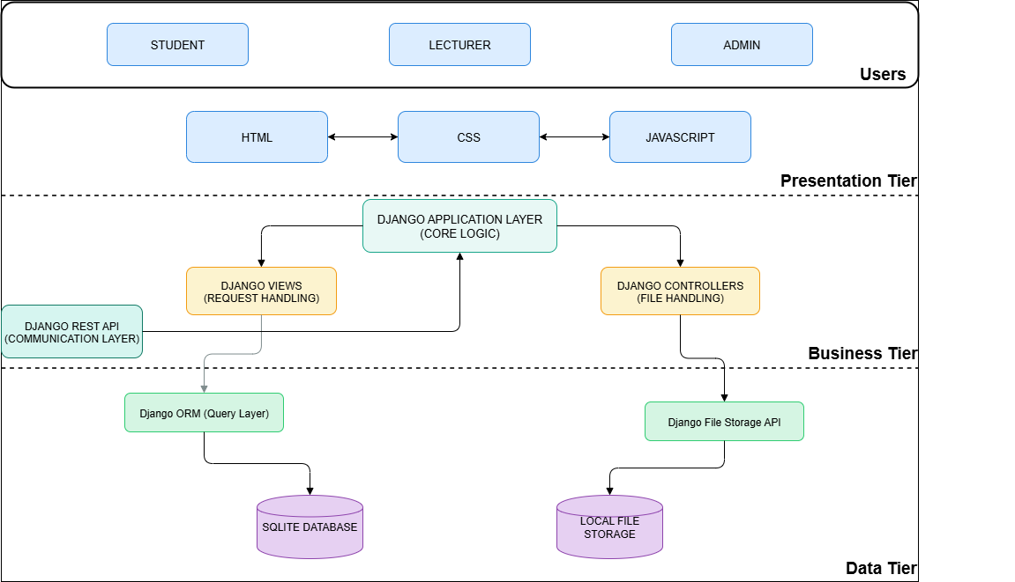
This layered design is promoting efficient processing, secure data handling, and flexibility for future system enhancements, as represented in the architectural diagram below.
Figure 3.1: The System Architecture Diagram

3.2.2 The System Flowchart
The system flowchart (see Figure 3.2) illustrates the main workflow for user authentication, course registration, material management, assignment submission, grading, and notification delivery. Decision branches account for role-based access, eligibility checks, and exception handling (e.g., registration failures, late submissions).
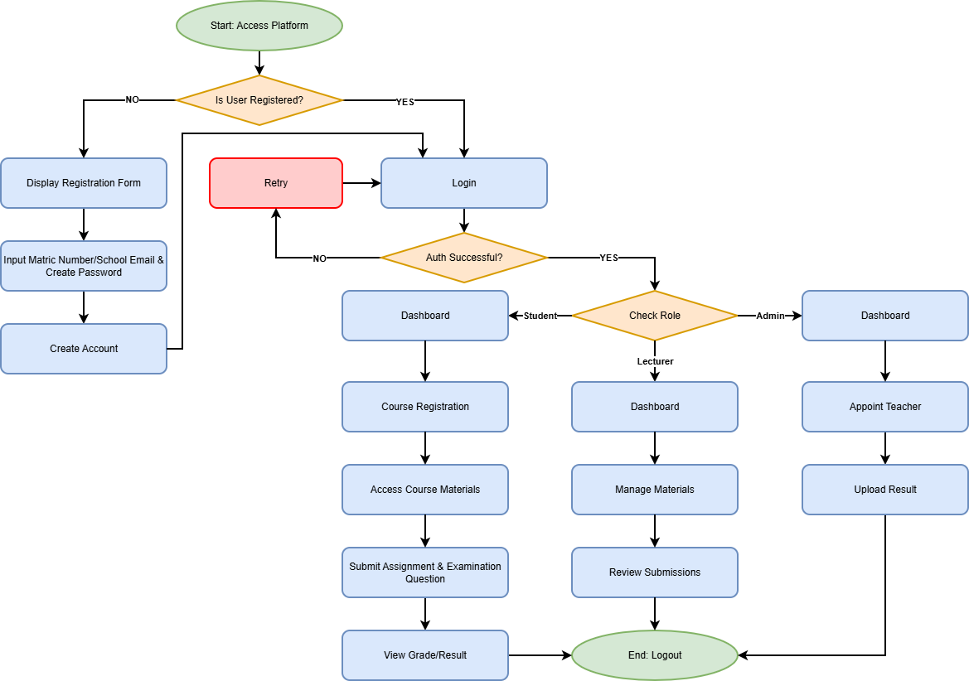Figure 3.2: System Flowchart

3.2.3 Data Flow Diagram (DFD)
The Data Flow Diagram (see Figure 3.3) depicts how information would move through the GEDs Management System:
- Users submit data via forms
- The system validates and processes registration or material access
- Data is routed to the correct storage layer (assignments, results, materials)
- Admin and lecturers can access reports, analytics, and student performance metrics via dashboards

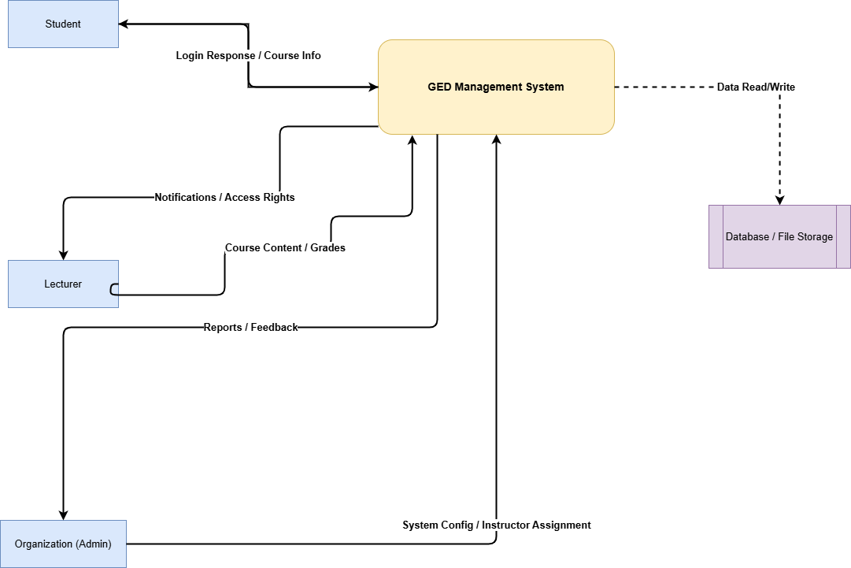
Figure 3.3: Data Flow Diagram
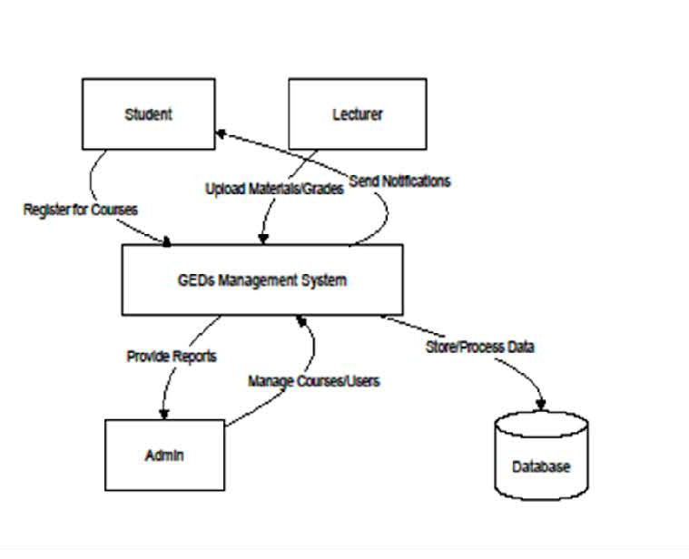
Figure 3.3: Data Flow Diagram

3.2.4 Use Case Diagram
The Use Case Diagram (see Figure 3.4) summarizes all major interactions: Actors:
- Student
- Lecturer
- Admin
Use Cases:
- Register account
- Enroll in GEDs courses
- Upload/download course materials
- Submit/view assignments and results
- Generate reports
- Manage users and courses
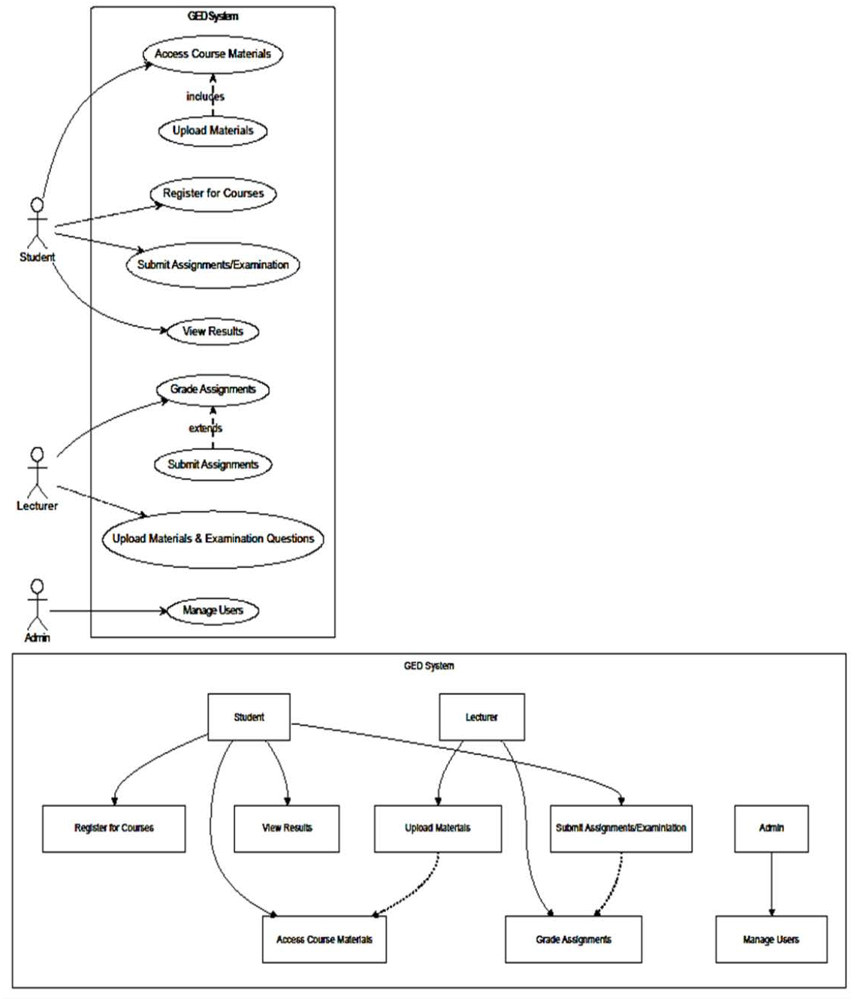
Figure 3.4: Use Case Diagram

3.2.5 Database Design
The database design of the Specialized GEDs Management System is defining how data is being structured, stored, and related within the system. It is serving as the foundation for all information management, ensuring data integrity, consistency, and easy retrieval. The design is being implemented using SQLite, which provides a lightweight yet reliable relational database structure suitable for web-based applications.
The database is being organized around several key entities that reflect real-world components of the General Studies program. These entities include Users, Organizations, Teachers, Students, Courses, Modules, Videos, Comments, Notes, and Quizzes. Relationships among these entities are being established through primary and foreign keys, allowing the system to efficiently manage one-to-many and many-to-many associations.
For example, each Organization is linked to multiple Teachers, and each Teacher is creating several Courses. Each Course is containing multiple Modules and Videos, while Students are enrolling in various Courses and participating in Quizzes. Additionally, Videos are allowing Comments and Notes, promoting interactive learning and collaboration.
This relational structure is supporting seamless synchronization between the academic and administrative aspects of GEDs management. By enforcing referential integrity and normalization, the system is minimizing redundancy and ensuring that all stored information remains accurate and consistent across all tiers of operation.
The logical structure of these entities and their relationships is being illustrated in the Entity–Relationship (ER) Diagram that follows.
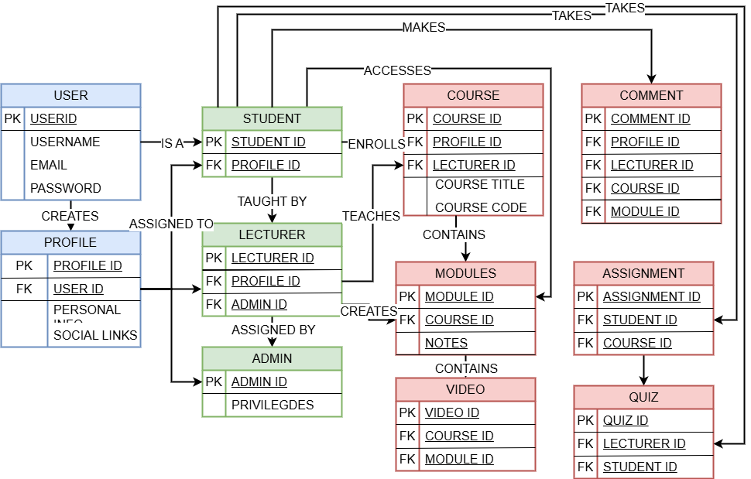
Figure 3.5: Entity Relationship Diagram

3.2.6 Input Design
The input design is defining how users are entering and submitting data within the system. User inputs are being collected through web forms developed with HTML, CSS, and JavaScript, while validation is being handled by Django’s form and model controls.
Key inputs include registration details, course information, quizzes, comments, and notes. Each form is designed to be intuitive, preventing invalid or duplicate entries. This ensures accurate data capture and smooth system operation across all user roles.

3.2.7 Output Design
The output design is determining how processed information is being presented to users. The system is displaying data dynamically through dashboards and reports generated by Django templates.
Students are viewing course progress and quiz results, lecturers are accessing performance analytics, and administrators are monitoring overall activities. The outputs are designed to be clear, interactive, and updated in real time for effective decision-making.

3.3 Requirement Analysis
The requirement analysis is providing a detailed specification of what the Specialized GEDs Management System is expected to achieve and the conditions under which it is performing. It is identifying the system’s core features, user expectations, and performance standards necessary to support efficient management of General Studies programs.
This section is divided into functional requirements, which define what the system is doing, and non-functional requirements, which describe how the system is performing, together these requirements are forming the foundation for system design, implementation, and evaluation.

3.3.1 Functional Requirements
The functional requirements are outlining the specific operations that the system is carrying out to meet user and institutional needs. These requirements are directly aligned with the system’s objectives of centralizing and automating GEDs management.
- User Management: The system is allowing users to register and authenticate securely using Django’s authentication framework. Each user is being assigned a specific role which is Student, Lecturer, or Organization (Administrator) which determines their permissions and accessible modules. Token-based sessions and cookies are being used to maintain login security.
- Course and Module Management: Lecturers are being able to create, edit, and manage courses and modules. Each course is being associated with relevant metadata such as organization, instructor, tags, and description. The system is allowing the upload of videos, notes, and additional learning materials under each module.
- Enrollment Management: Students are enrolling in available courses through the system interface. Once enrolled, the system is automatically associating the student’s profile with the selected course, enabling access to course materials and progress tracking.
- Quiz and Assessment Management: Lecturers are creating quizzes tied to specific videos or modules. Each quiz is containing multiple questions and answers, and the system is evaluating student responses automatically while recording attempt data for performance analysis.
- Progress Tracking and Analytics: The system is continuously tracking student engagement, quiz attempts, and course completion rates. Both lecturers and administrators are accessing analytics dashboards that visualize progress and performance metrics.
- Communication and Interaction: The platform is facilitating communication through comments and sub-comments on videos and modules. Students are adding personal notes for revision, and instructors are responding to queries, promoting collaborative learning.
- Administrative Oversight: Organizations are overseeing platform operations. They are appointing lecturers, managing institutional data, and monitoring performance across all GEDs courses within their domain.

Together, these functional requirements are ensuring that the system fulfills its purpose as a centralized academic and administrative hub for managing General Studies activities effectively.

3.4.2 Non-Functional Requirements
The non-functional requirements are describing the performance attributes and quality standards that the system must maintain during operation. These characteristics are ensuring reliability, efficiency, and user satisfaction.
- Performance: The system is being optimized to handle multiple simultaneous requests with minimal response time. Database queries and API endpoints are being structured to ensure fast and stable communication across all modules.
- Scalability: The architecture is being designed to support future expansion, allowing additional users, courses, and institutions to be integrated without compromising system performance.
- Security: All data transmissions are being protected through Django’s authentication framework and encrypted connections. Access control is being enforced through role-based permissions to prevent unauthorized actions.
- Usability: The interface is being designed to be simple, intuitive, and responsive, ensuring that users with varying technical backgrounds can navigate the system easily. Consistent design patterns and clear navigation paths are enhancing the overall user experience.
- Reliability: The system is ensuring continuous operation and minimal downtime. Error-handling routines are being implemented to detect and manage faults without disrupting active sessions.
- Maintainability: The application structure is following Django’s Model-View-Template (MVT) pattern, which promotes modularity and allows future updates, debugging, or feature enhancements to be implemented efficiently.
- Compatibility: The platform is supporting major browsers (Chrome, Firefox, Edge) and is responsive across devices, ensuring accessibility for all categories of users.
- Data Integrity: The system is enforcing validation and referential integrity at both the database and application levels. Backups are being scheduled to prevent data loss and maintain consistency during unexpected failures.
In summary, the requirement analysis is defining both the operational and qualitative expectations of the system. The functional requirements are ensuring that all necessary academic and administrative activities are being carried out effectively, while the non-functional requirements are guaranteeing that these operations are being performed securely, reliably, and efficiently within a scalable digital framework.

3.6 Development Tools
The development tools are representing the technologies, frameworks, and environments that are supporting the creation and deployment of the Specialized GEDs Management System. Each tool is being selected to enhance performance, maintain scalability, and ensure smooth integration across all system tiers.
Python is serving as the primary programming language for backend development, chosen for its readability, flexibility, and robust library ecosystem. It is providing the foundation for implementing business logic and system automation.
Django Framework is being used to structure the backend using the Model-View-Template (MVT) pattern, promoting modularity and reducing code redundancy. It is handling core functions such as authentication, routing, and data management.
Django REST Framework (DRF) is being integrated to manage communication between the frontend and backend, allowing seamless API interactions, data serialization, and secure authentication.
SQLite is acting as the database management system for structured data storage and retrieval. It is lightweight, serverless, and fully compatible with Django’s ORM, making it ideal for web-based academic systems.
HTML, CSS, and JavaScript are being used for the frontend interface, ensuring a responsive, interactive, and user-friendly design that enhances the learning experience.
Visual Studio Code is serving as the integrated development environment (IDE), providing debugging tools, syntax highlighting, and Git integration to support efficient coding and testing.
The Django Development Server is being used for local deployment and system testing, while Local File Storage is handling multimedia uploads such as videos and notes.

CHAPTER FOUR

IMPLEMENTATION

4.1 Introduction
This chapter describes in detail the implementation of the General Studies (GEDs) Management System developed for Babcock University. It describes how the Django web framework was used to convert the system design presented in Chapter Three into a workable web application. The system architecture, key modules, user roles, key features, and how each part works together to provide a simple, safe, and effective learning management system designed especially for General Studies (GEDs) classes are all highlighted in this chapter.
Usability, performance, scalability, and role-based access control were the main priorities during the implementation phase. With clearly defined roles and limited access to pertinent features, the system was created to assist administrators, instructors, and students.
Emphasis was placed on automating academic processes such as course registration, assessment grading, result computation, and content delivery, thereby reducing administrative workload and improving user experience all in one platform.

4.2 Graphical View of the Project
The system follows a typical web-based client–server architecture. The backend was developed using the Django web framework, which handles business logic, database interactions, authentication, authorization, and security. The frontend interfaces were built using HTML, CSS, JavaScript, Django templates and responsive design principles to ensure accessibility across different devices.
The graphical representation of the system illustrates the interaction between the three major user roles, the Administrator, Lecturers, and Students, and the central GEDs Management System. Each role accesses the system through authenticated login pages and is redirected to role-specific dashboards.
At a high level, the system consists of the following layers:
- Presentation Layer: User interfaces for students, lecturers, and administrators.
- Application Layer: Core logic for course management, assessments, grading, quizzes, and reporting.
- Data Layer: Database models managing users, courses, sessions, semesters, assessments, and results.
Screenshots showing system flow, User interface, dashboards, course pages, assessment pages, etc. will be included to visually represent each module.

4.3 System Modules and Feature Implementation

4.3.1 User Authentication and Access Control
The system implements a secure authentication mechanism using Django’s built-in authentication framework. Users are categorized into three roles: administrators, lecturers, and students. Page access restriction is enforced to ensure that each user only interacts with features relevant to their role.
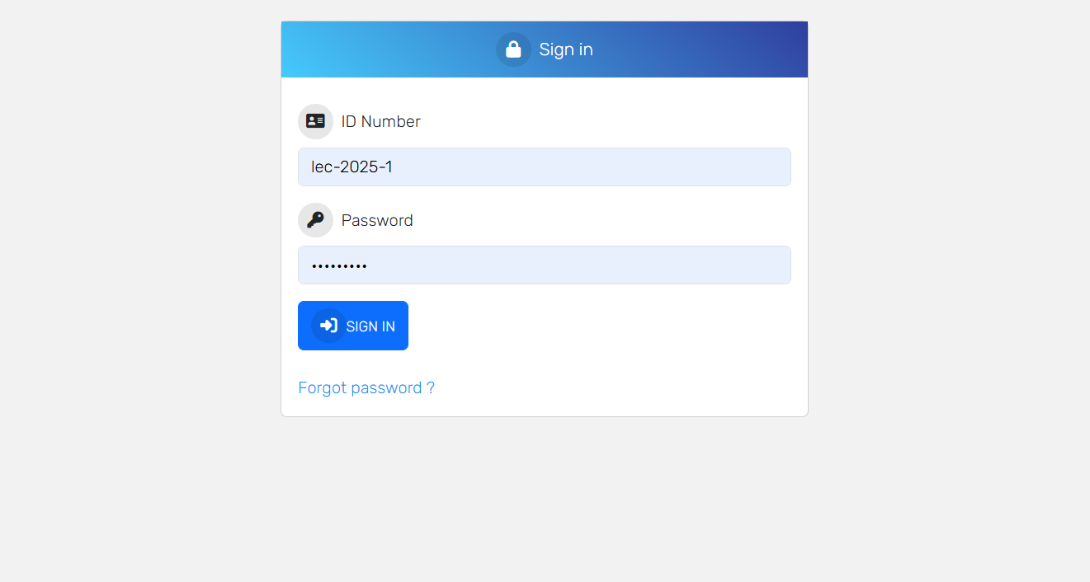
Figure 4.1 Visual Interface of User Authentication
Custom permissions were implemented, such as the view settings permission, which allows authorized users to view only features relevant to their role in the system. This enhances system security while maintaining flexibility in access control.

4.3.2 Administrator Module
The Admin Module represents the highest level of control within the Specialized General Studies (GEDs) Management System. It is designed to give authorized administrators a comprehensive overview and full administrative control over academic and system-related activities.
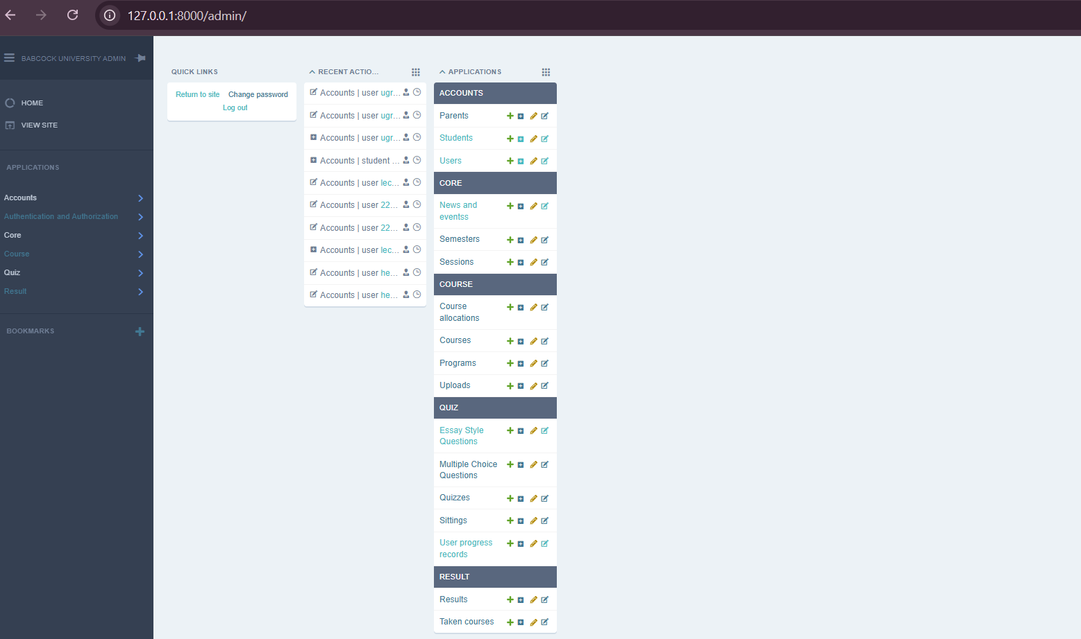
Figure 4.2 Visual Interface of Administrator module (Django frontend view)
Upon successful authentication, administrators are redirected to a centralized dashboard that summarizes institutional data and recent system activities.
The admin dashboard displays school demographics, including the number of students, lecturers, administrators, and other academic and non-academic roles supported by the system such as supervisors, librarians, laboratory assistants, and office assistants. This demographic breakdown enables administrators to monitor system usage and institutional participation at a glance.
The dashboard also includes a Latest Activities panel, which logs real-time system actions such as course creation, course updates, and program additions. This activity log improves transparency, accountability, and auditability of administrative actions within the system.
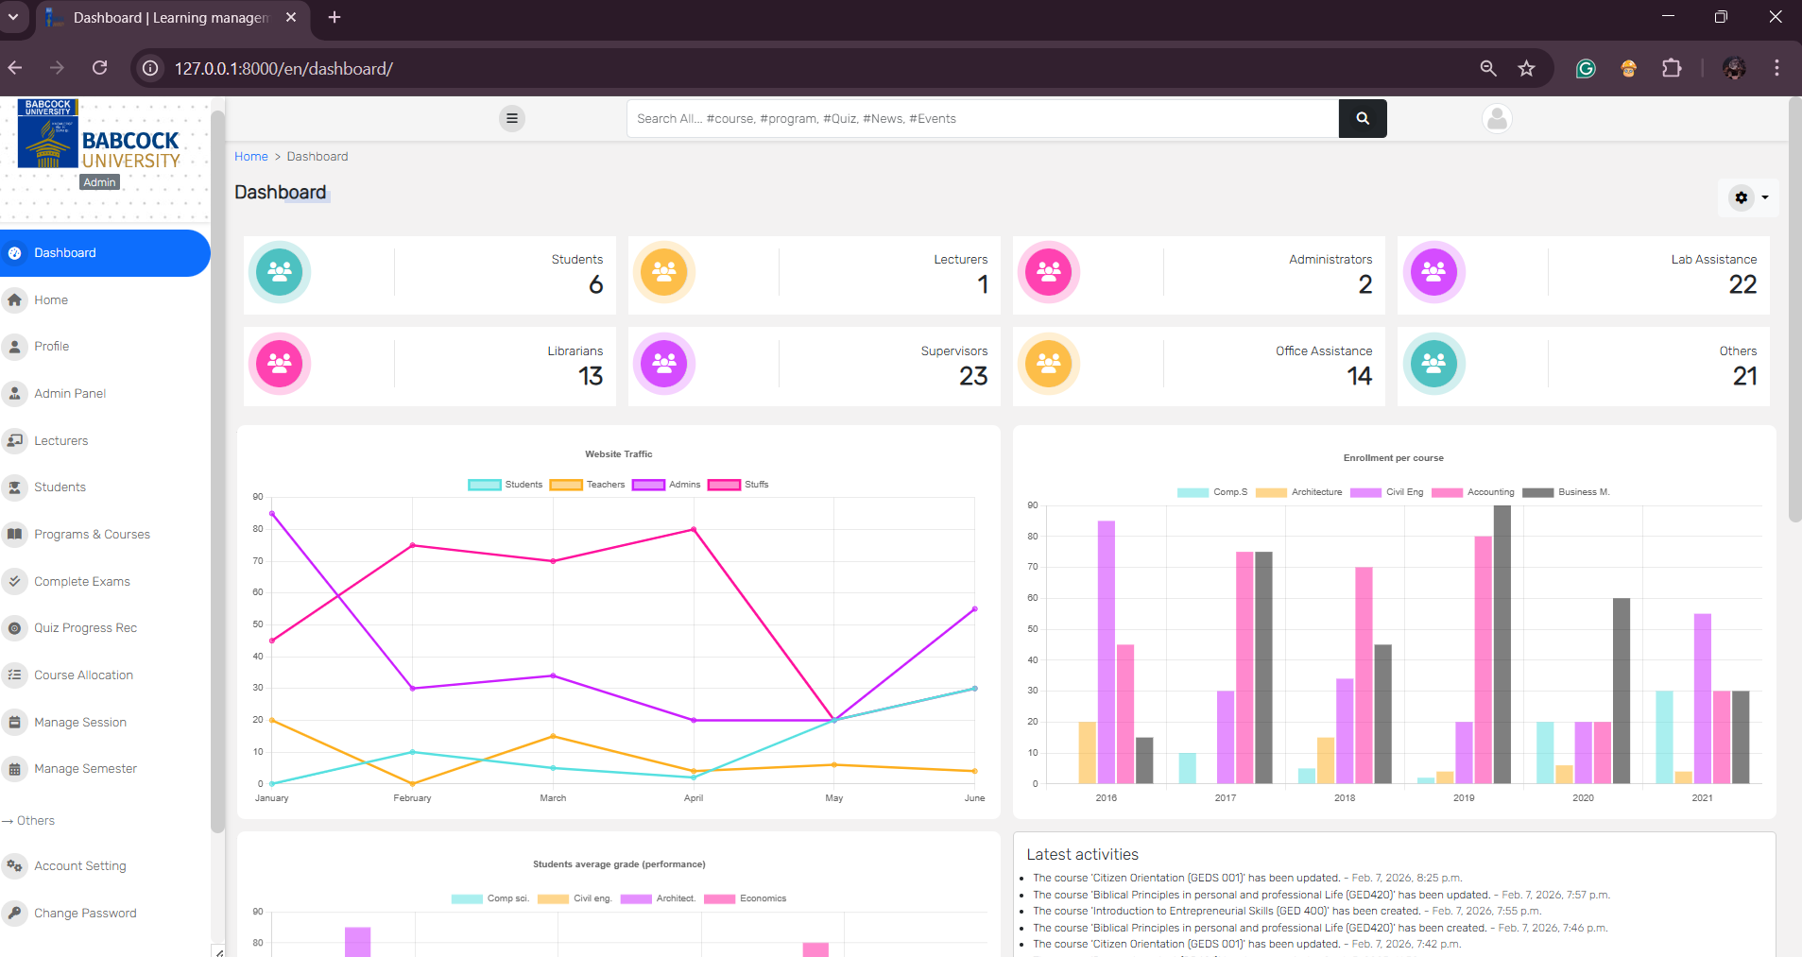
Figure 4.3 Visual Interface of Administrators Dashboard
Through the Admin Panel navigation, administrators can perform the following core functions:
- User Management: Create, update, and delete records for students, lecturers, and other system users.
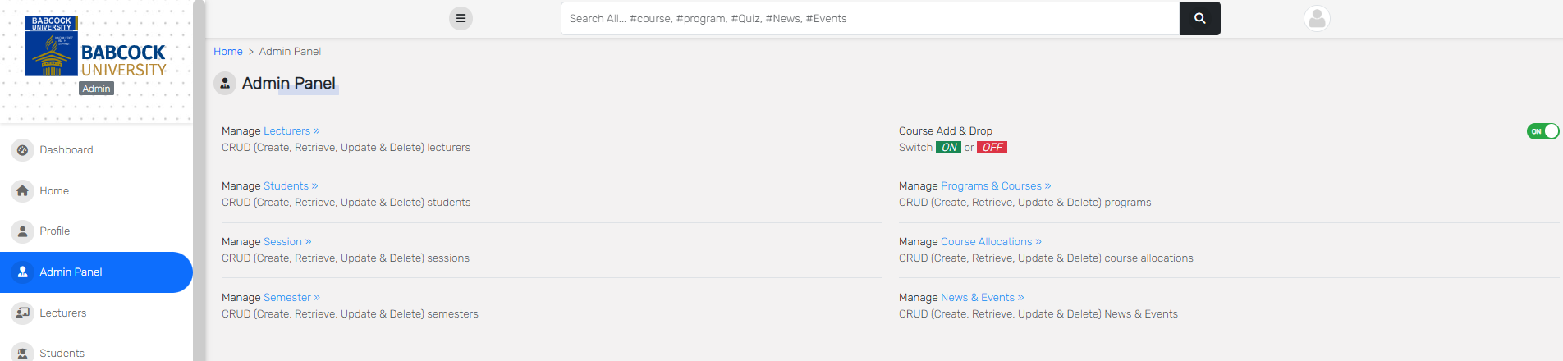
Figure 4.4 Visual Interface of User management module

- Programs and Courses Management: Create and manage academic programs and General Studies courses, including course codes and titles.
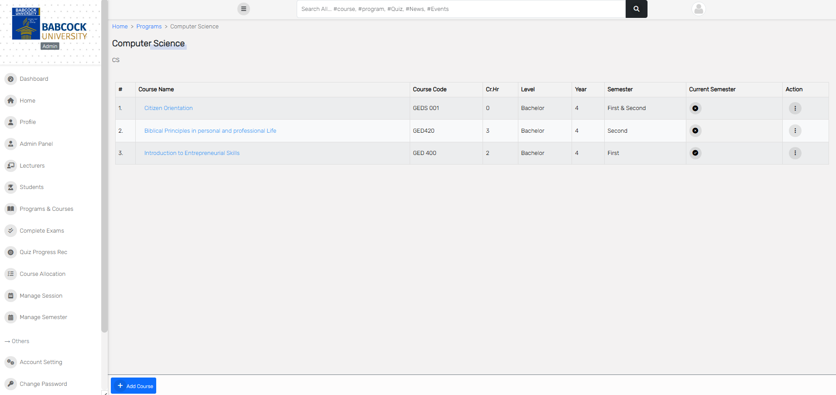
Figure 4.5 Visual Interface of Program & Course management module
- Course Allocation: Assign lecturers to specific GEDs courses to ensure proper course delivery.
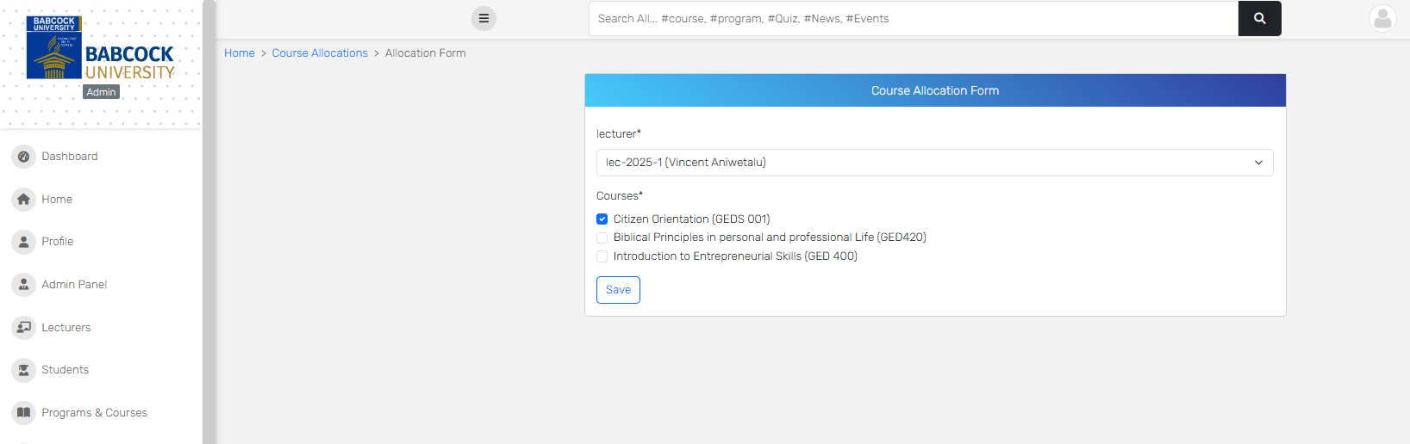
Figure 4.6 Visual Interface of the Course allocation module
- Session and Semester Management: Define and manage academic sessions and semesters, which serve as the basis for course registration, assessments, and result computation.
- Examination and Assessment Oversight: Monitor completed examinations and assessments across courses and semesters.
- Quiz Progress Records: Track quiz participation and performance statistics across users and categories.
Additional administrative features include profile management, account settings, password management, system-wide search functionality, and multilingual interface support. Page access restrictions ensure that only authorized administrators can access sensitive system features.

4.3.3 Student Module
The Student Module provides a personalized academic workspace for Babcock university students. Upon login, students are directed to a dedicated homepage that offers quick access to the News and Events section, which serves as an information hub for institutional announcements, academic programs, workshops, and special events related to teaching, learning, and research. This ensures that students remain informed about important academic and extracurricular developments within the university.
Through the student navigation panel, users can effectively manage their academic activities using the following features:
- Courses & Course materials: View all registered General Studies courses for the current session and semester with their course materials being posted by the lecturer.
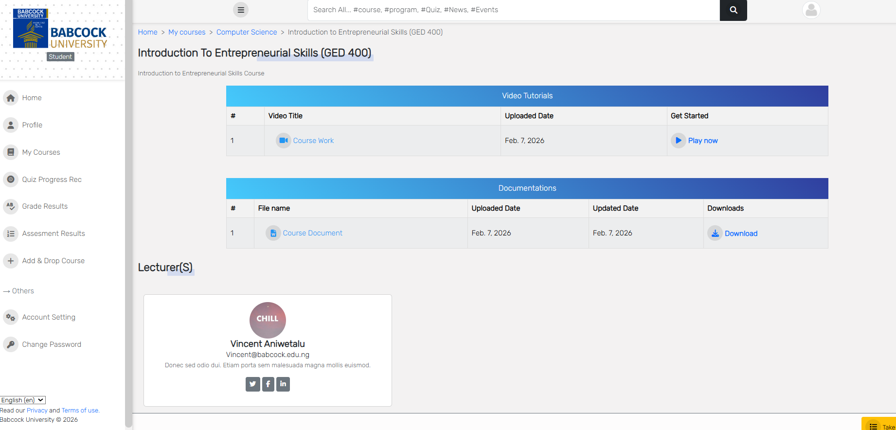
Figure 4.7 Visual Interface of courses/ course materials module
- Add and Drop Courses: Perform course registration adjustments within the approved academic period.
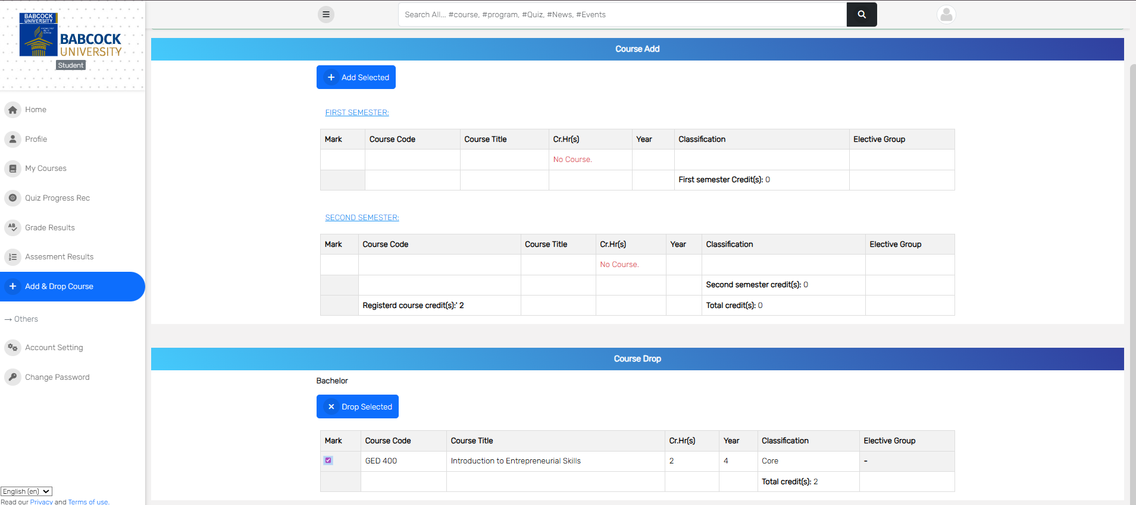
Figure 4.8 Visual Interface of the add & drop courses module

- Assessment Results: Access detailed assessment breakdowns for attendance, assignments, mid-semester examinations, and final examinations.
- Grade Results: View final grades, grade points, averages, and grade comments generated automatically by the system.
- Quiz/Exam Module: Take Quiz, Examination and assignment, View scores, and performance trends across different quiz categories.

Figure 4.9 Visual Interface of Quiz Progress Record
Students are also able to participate in quizzes directly from the platform, resume incomplete quizzes when allowed, and review previous quiz performance where permissions apply. The system groups academic records by session and semester, making it easier for students to track their academic progress over time.
Additional features such as profile management, account settings, password change, global search functionality, and multilingual support enhance usability and personalization. Page access restriction ensures that students can only view and interact with their own academic data, thereby maintaining privacy and data integrity.
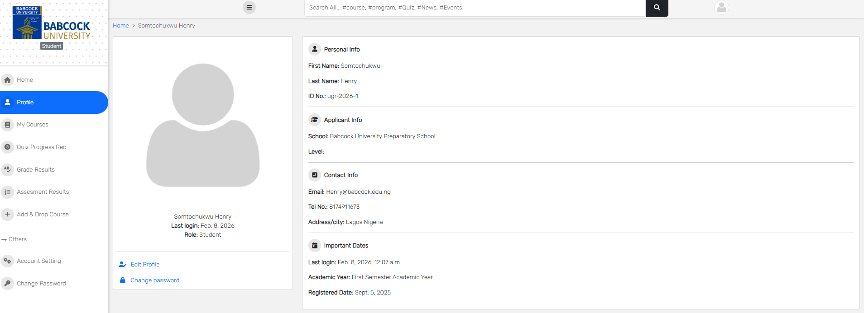
Figure 4.10 Visual Interface of the profile management module
Overall, the Student Module promotes a structured, transparent, and engaging learning experience by centralizing all General Studies academic activities within a single platform.

4.3.4 Lecturer Module
The Lecturer Module is designed to support effective course and course material delivery and accurate student evaluation within the General Studies (GEDs) Management System. After authentication, lecturers are directed to a role-specific dashboard that provides access to News, assigned courses and academic management tools.
The lecturer interface provides the following functionalities:
- Dashboard Access: Lecturers are presented with a personalized home page showing News & Events, assigned courses and quick access to academic functions.
- Course Allocation: View all allocated General Studies (GEDs) courses, organized by academic session and semester with lecturer(s) assigned to each.
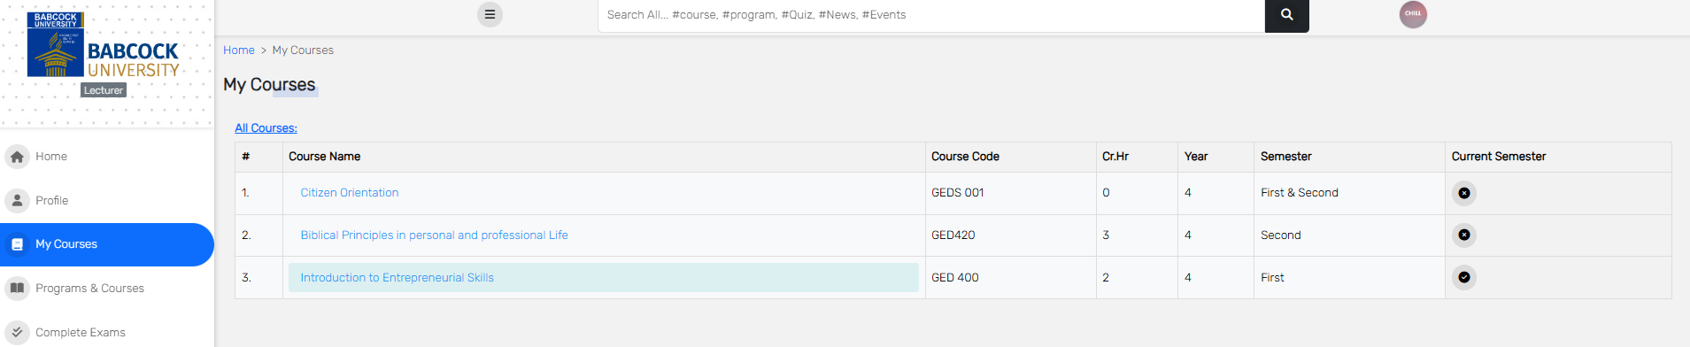
Figure 4.11 Visual Interface of the course allocation module
- Programs and Courses: Access course information, outlines, and program details approved by the lecturer or administrator.
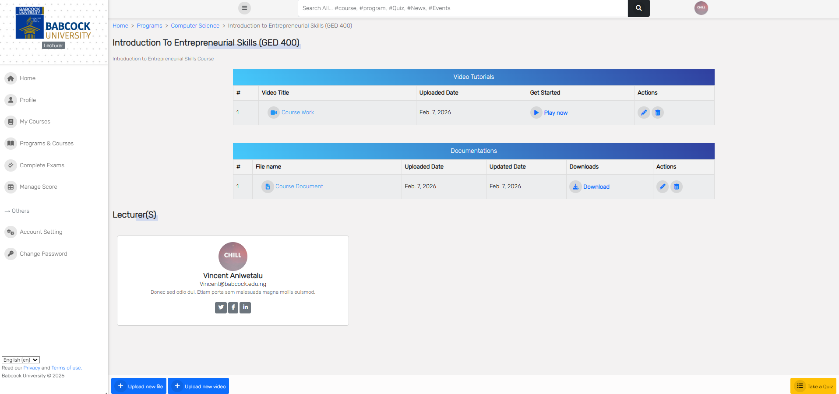
Figure 4.12 Visual Interface of the program & course module
- Manage student assessments: to enter and manage student assessment scores, including, Assignment scores, Quiz scores, Attendance records, Mid-semester examination scores and Final examination scores.
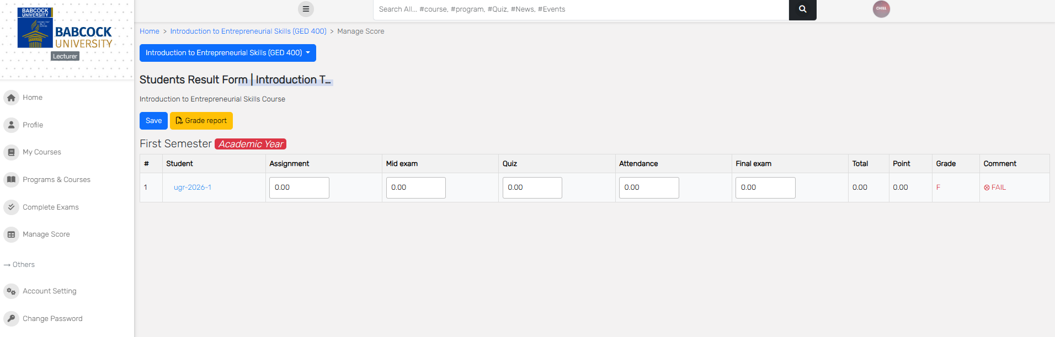
Figure 4.13 Visual Interface of the student assessment management module

- Automated Grading: The system automatically computes, total score, grade point, Letter grade and Grade comment (e.g., Pass or Fail).
- Complete Exams: Review and confirm finalized assessments and submitted results for each course and semester.
- Result Validation: Ensure accuracy and completeness of student academic records before final submission.
- Access Control: Lecturers can only manage courses and view results assigned to them by the administrator.
- Account Management: Update profile information, change password, and manage account settings.
- Search and Language Support: Use system-wide search functionality and multilingual interface options.
The Lecturer Module streamlines assessment management, reduces grading errors through automation, and provides a clear and structured workflow for monitoring and evaluating student academic performance.

4.3.5 Assessment and Grading Module
The assessment module is one of the core components of the system. It supports multiple assessment types and ensures accurate academic evaluation.
Features include:
- Automatic calculation of total scores, averages, grade points, and grades
- Grade comments such as Pass, Fail, and Pass with Warning
- Semester-based grouping of assessments and results
- Assessment and grade result pages for students
These features ensure transparency, consistency, and efficiency in academic evaluation.
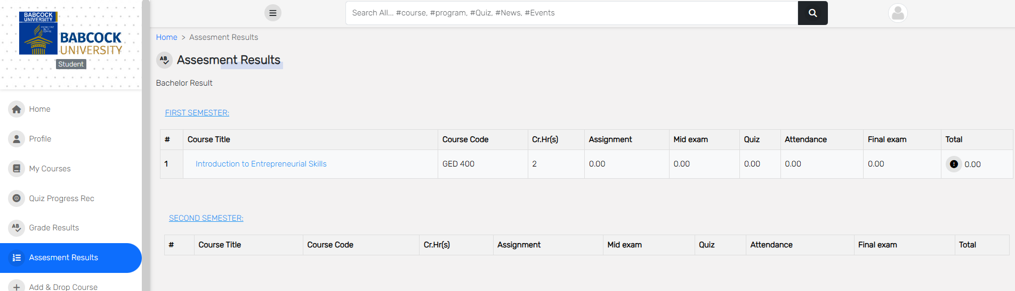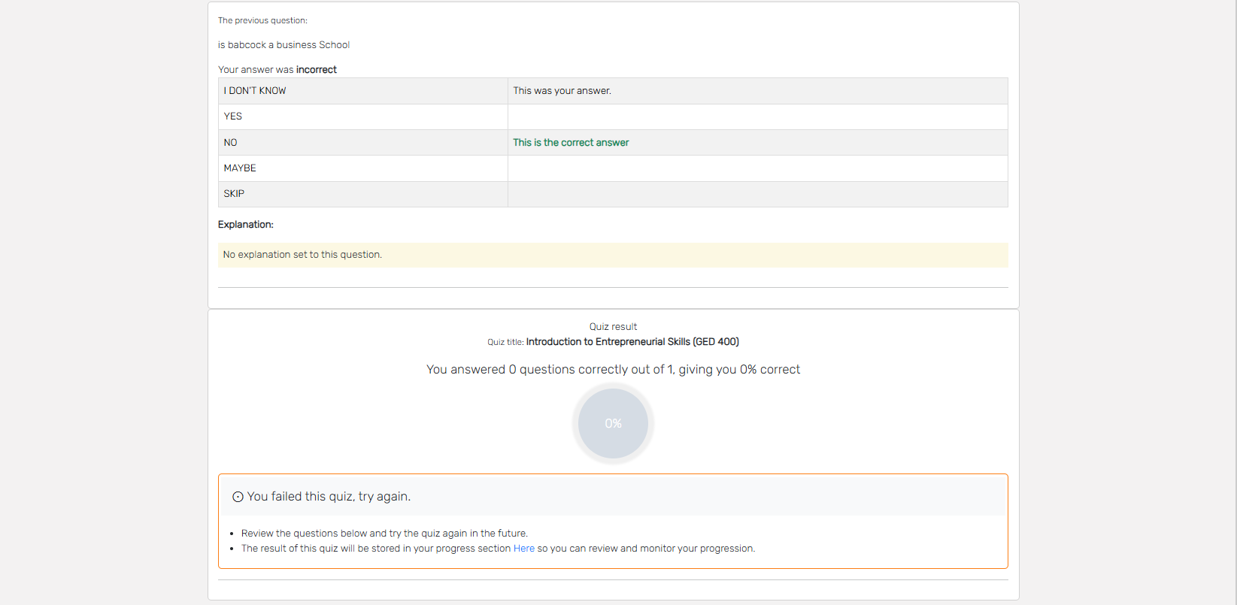
Figure 4.14 Visual Interface of the Assessment and grading module
4.3.6 Quiz, Exam or Assignment Management Module
The quiz module enhances interactive learning and continuous assessment.
Key features include:
- Multiple-choice and True/False question types
- Question categorization and randomization
- Pass mark configuration
- Single-attempt quiz enforcement
- Viewing previous quiz scores
- Display of correct answers (immediate or end-of-quiz)
- Explanations for each question result
- Custom messages for pass or fail outcomes
A marking page allows authorized users to review completed quizzes and grade essay-based questions where applicable.
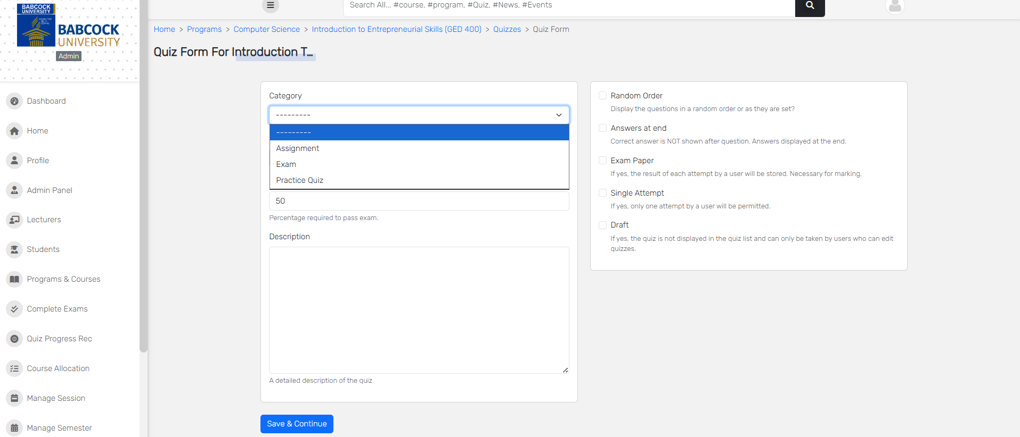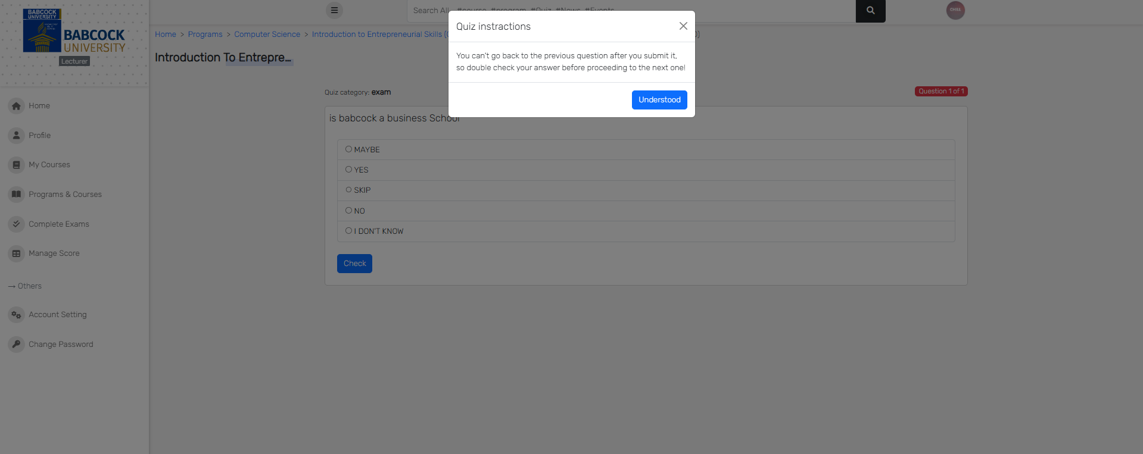
Figure 4.15 Visual Interface of the Quiz, Exam or Assignment Management Module
4.3.7 Reporting and PDF Generation
The system includes a PDF generation feature that allows students to download official registration slips and academic results. This feature enhances accessibility and provides students with verifiable academic documents.
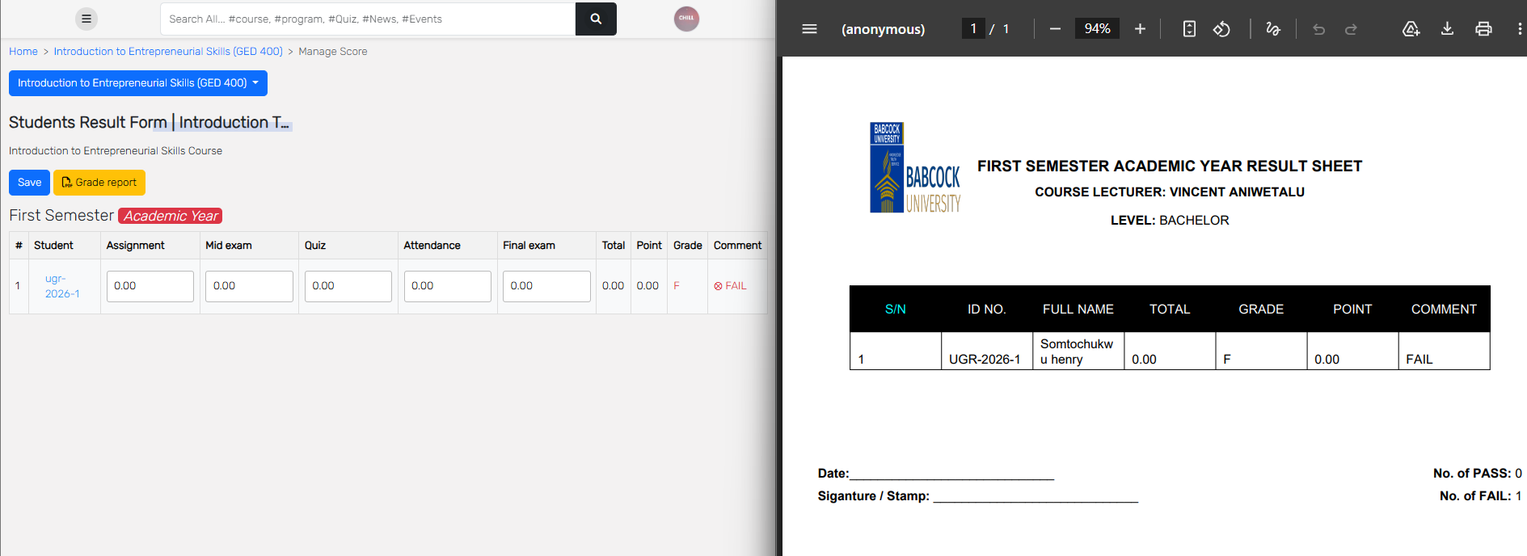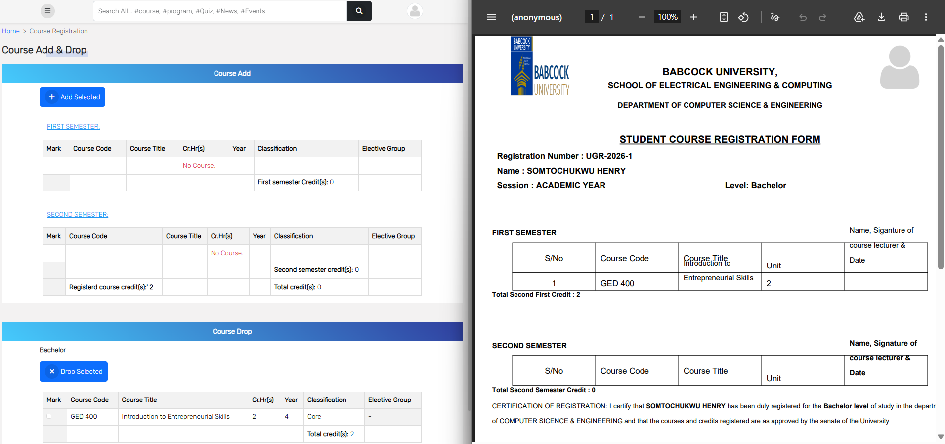
Figure 4.15 Visual Interface of some Reporting and PDF Generation module

4.4 System Testing and Validation
System testing was carried out using realistic academic scenarios to evaluate functionality, usability, and performance. Unit testing and integration testing ensured that individual modules and interconnected components functioned correctly. User acceptance testing validated that the system met the needs of administrators, lecturers, and students.

4.5 Conclusion
This chapter has presented the implementation details of the General Studies (GEDs) Management System. The chapter demonstrated how the proposed system design was successfully transformed into a fully functional, scalable, and secure web-based platform. The system effectively addresses the challenges associated with managing General Studies courses and provides a unified academic environment for Babcock University.

CHAPTER FIVE

SUMMARY, CONCLUSION AND RECOMMENDATION

5.1 Summary
This study focused on the design and implementation of a General Studies (GEDs) Management System for Babcock University. The project addressed limitations in existing academic management platforms that lacked features tailored to the transdisciplinary nature of General Studies courses.
Through the use of the Django web framework, the system provided role-based access, automated grading, course management, quiz administration, and centralized access to learning materials. The system improved efficiency, reduced administrative overhead, and enhanced the overall academic experience for students and lecturers.

5.2 Conclusion
The implementation of the Specialized General Studies (GEDs) Management System demonstrates that a focused and purpose-built platform can significantly improve the management of transdisciplinary courses. The system successfully bridges gaps found in existing university-wide platforms by offering features specifically designed for GEDs.
The system is scalable, secure, and adaptable, making it suitable for future expansion and integration with existing university systems such as UMIS. Overall, the project achieved its aim and objectives and provides a strong foundation for digital academic management within the university.

5.3 Recommendation
It is recommended that future work on this system include integration with the university’s UMIS platform for seamless data synchronization. Additional features such as mobile application support, advanced analytics, real-time notifications, and AI-driven performance insights can further enhance system functionality.
The system can also be adapted for other departments or institutions with similar transdisciplinary course structures. Continuous evaluation and user feedback should be encouraged to improve system performance, security, and usability over time.

References
(n.d.).
Adedoyin, A. E. (2023). Design and implementation of an online teaching and learning management system. FUDMA Journal of Sciences (FJS).
Ayanbode, O. F. (2022). Students’ interactions, satisfaction, and perceived progress in an online class: Empirical evidence from Babcock University Nigeria. Cogent Education.
Bayode, O. A. (2022). Design and implementation of school management system. National Open University of Nigeri.
Decuypere, M. G. (2021). Introduction: Critical studies of digital education platforms. Critical Studies in Education.
Fibriasari, H. A. (2023). Learning management system now and in the future: Study case from the Indonesian university students. International Journal of Information and Education Technology.
Ike, I. (2023). Design and implementation of a student information system. Federal University Otuoke.
National Universities Commission. (2023). Core Curriculum and Minimum Academic Standards (CCMAS) for Nigerian Universities. Abuja: National Universities Commission.
Rohit, G. P. (2021). E-learning: Developing tomorrow’s education. Proceedings of the 13th International Scientific and Practical Conference. Rezekne Academy of Technologies.
Sofi-Karim, M. B. (2022). Online education via media platforms and applications as an innovative teaching method. Education and Information Technologies.
Vlasenko, K. V., Volkov, S. V., Lovianova, I. V., Chumak, O. O., & Sitak, I. V. (2021). Management of Online Platform Development and Support Process. CTE Workshop Proceedings, Volume 8 , (pp. 1-14).
Wong-Fajardo., E. M. (2021). DESIGN AND IMPLEMENTATION OF AN INTEGRATED ACADEMIC MANAGEMENT MODEL WITH LMS: A PERUVIAN PRIVATE UNIVERSITY STUDY CASE. CEUR Workshop Proceedings.
Zhang, Z. (. (2024). Design and implementation of general education courses system based on curriculum network. Proceedings of the 4th International Conference on Internet, Education, and Information Technology (IEIT 2024).

